**Python**

**The Premier Guide**

**Sriram**

**BY**

**SRIRAM**

Table of Contents

|  |  |
| --- | --- |
| Sl. No | Python Topics |
| 1 | **Introduction to Python** |
| 2 | **Basics of Python** |
| 3 | **Program Flow Control** |
| 4 | **String Manipulation** |
| 5 | **List Manipulation** |
| 6 | **Tuple, Set Manipulation** |
| 7 | **Dictionaries Manipulation** |
| 8 | **Functions, Modules & Packages** |
| 9 | **OOPs & Exception Handling** |
| 10 | **File Handling** |
| 11 | **NumPy, Pandas, Matplotlib, SciPy** |
| 12 | **Database** |
| 13 | **Networking & Multithreading** |
| 14 | **Web Python** |
| 15 | **Python Certification Practice** |

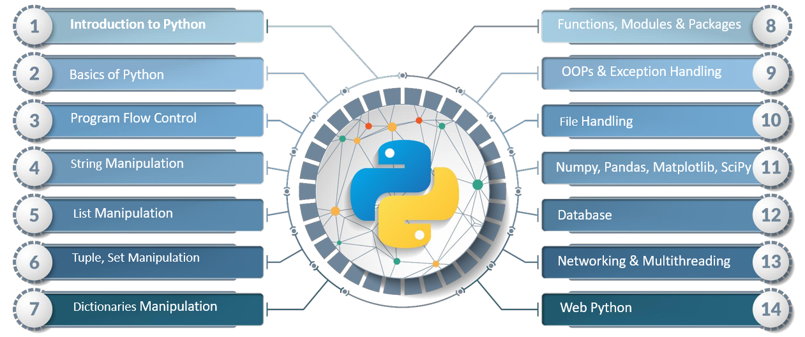

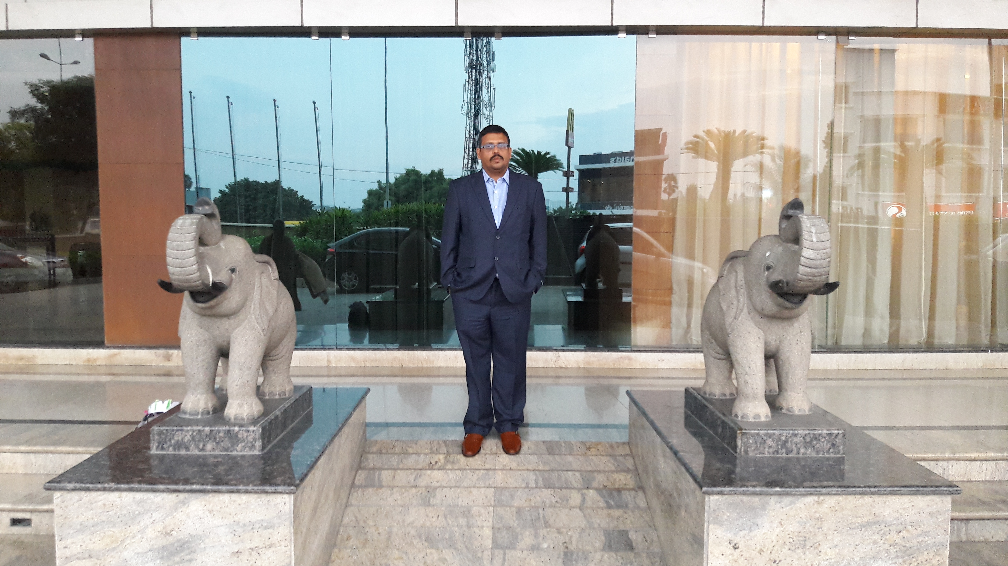

**Sriram – Artificial Intelligence Architect**



**Guido Van Rossum – Father of Python**